**CREATE AN ACCOUNT IN SENDGRID**

**SENDGRID INSTALLATION:  
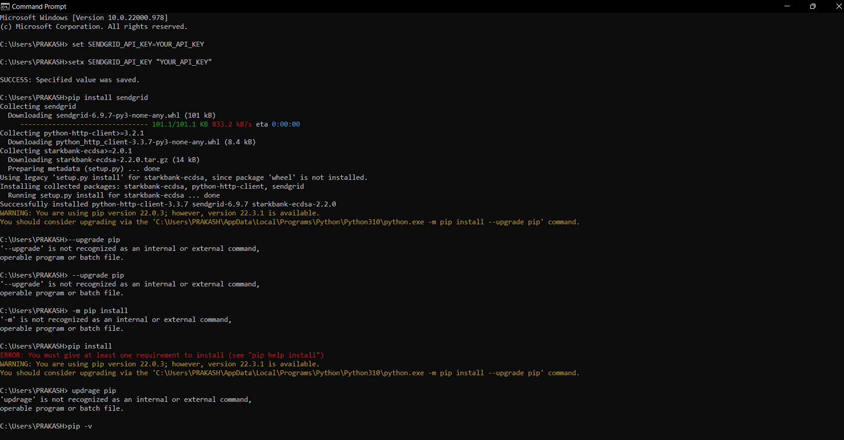**

**ACCOUNT CREATION IN SENDGRID**

